## Creating directory and Docker image

## Creating the Dockerfile and Index.HTML

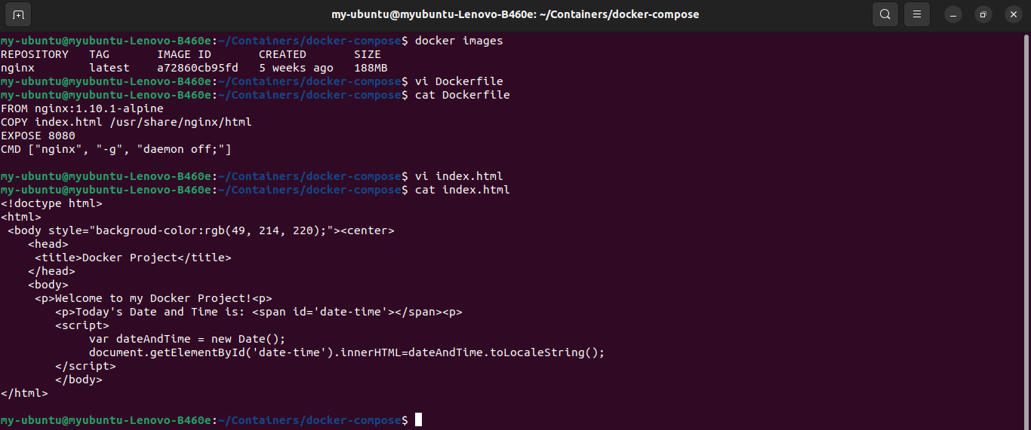

## Build the image

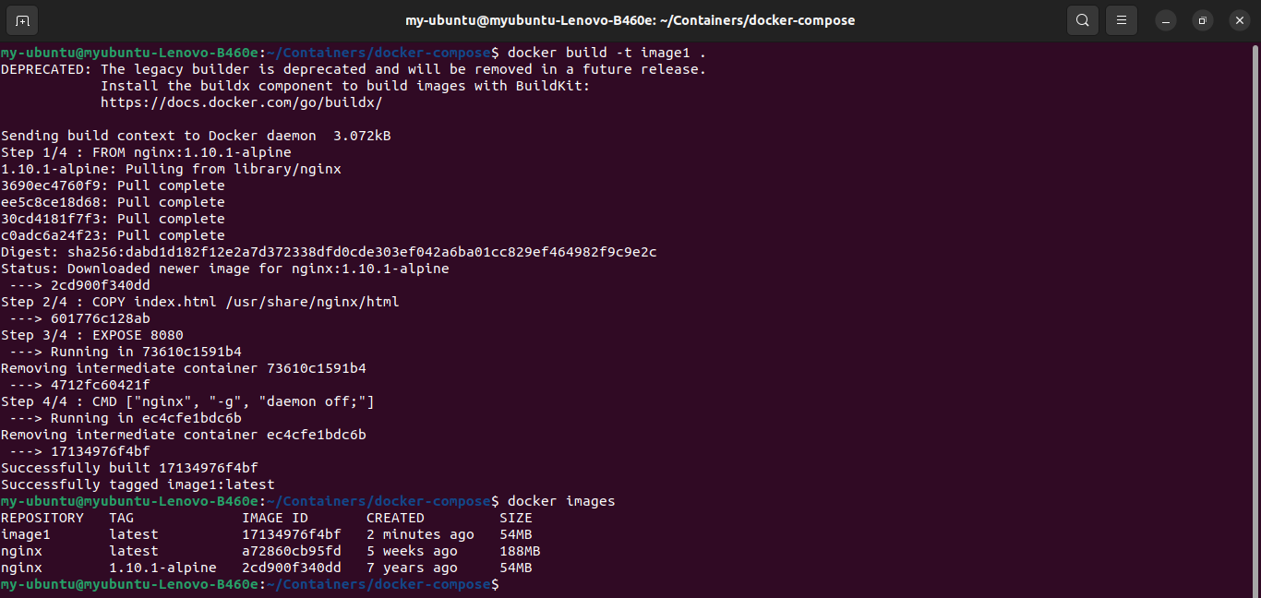

## Building and deploying the container

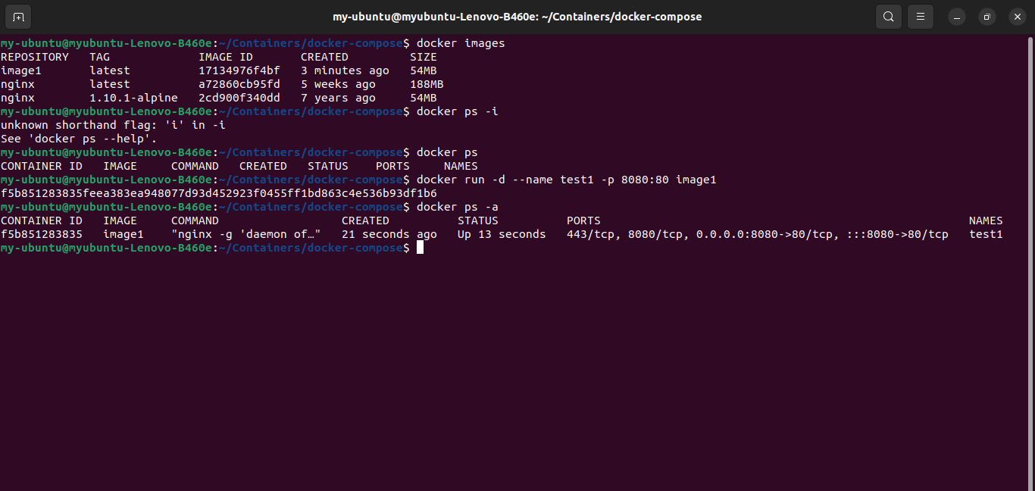

## Verified and the container is running

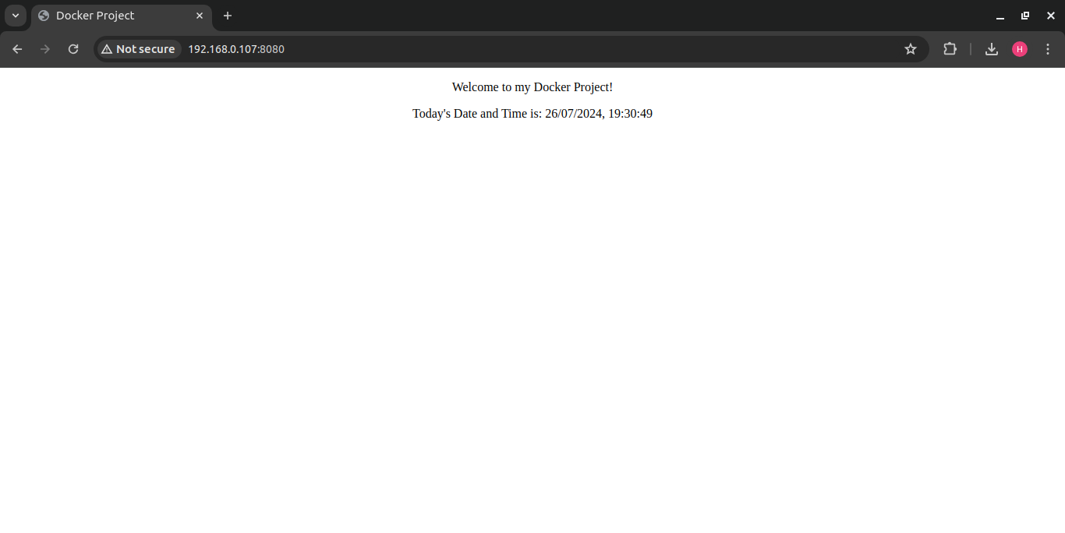

Deployed using docker compose

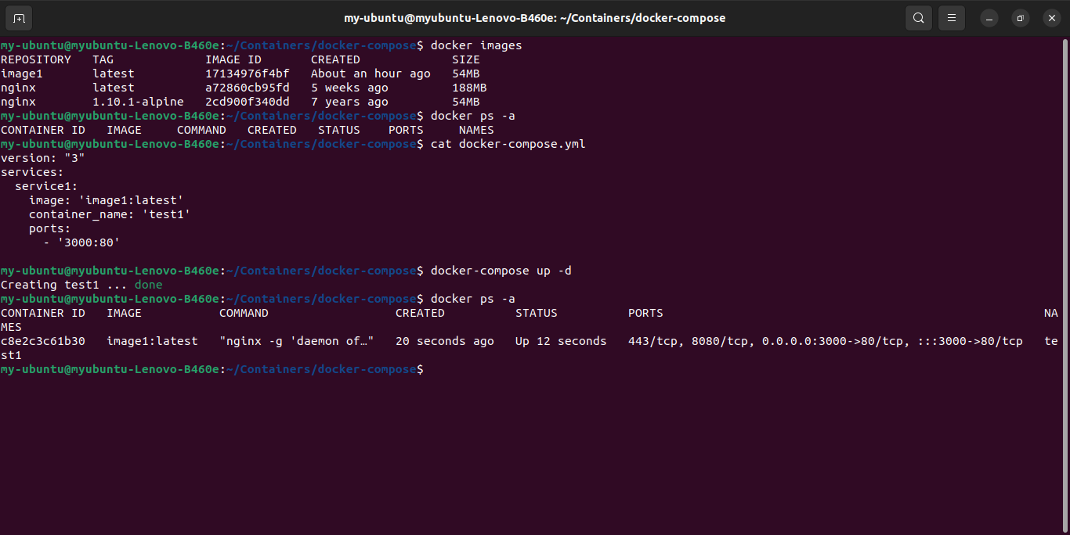

Signed up to docker hub and created repository

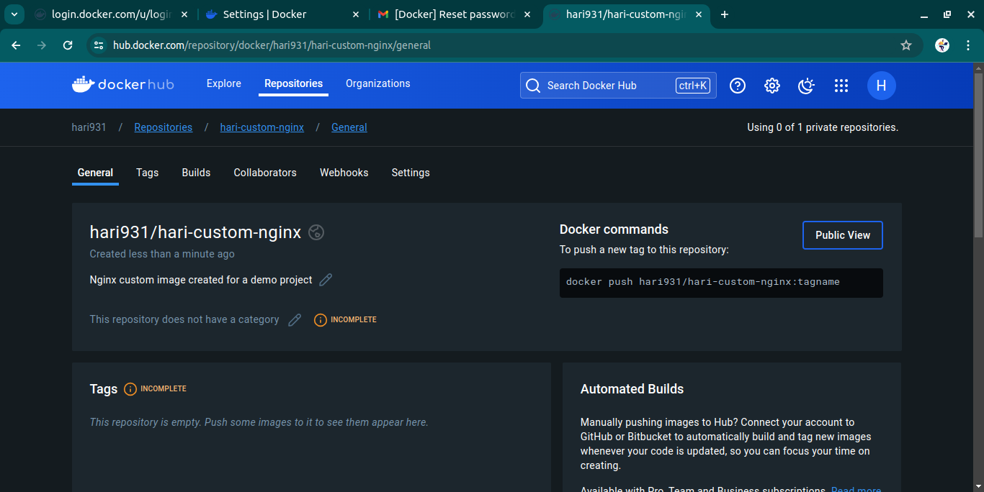

Builded image using docker hub respository

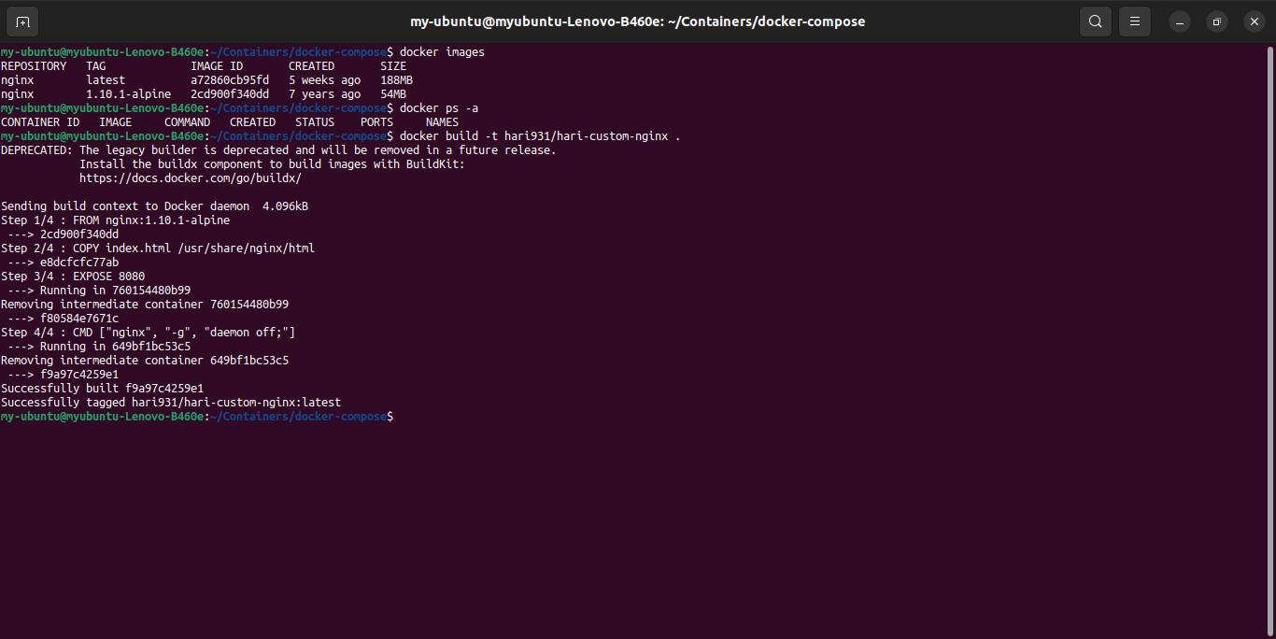

Pushing Docker image to a Repository

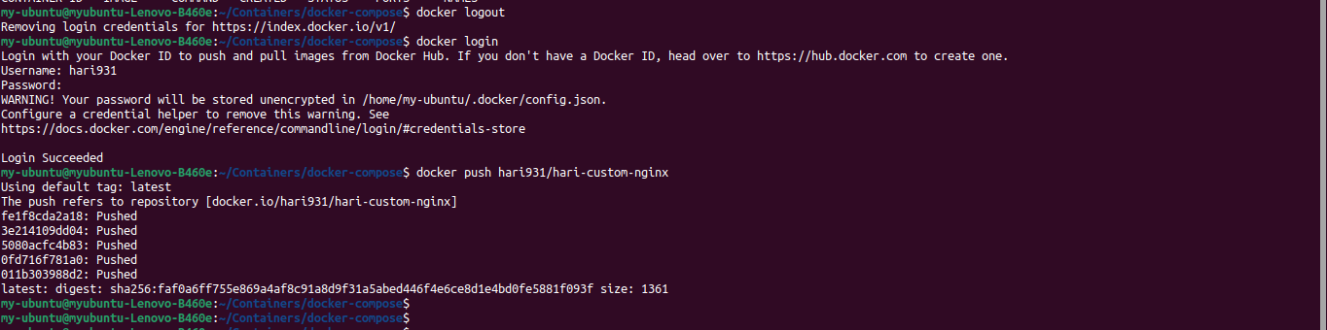

Snap from docker hub showing the pushed image

